HW 2

Questions
- Show that the geometric mean 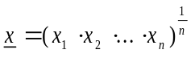 which could also be expressed as 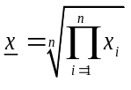minimizes the function 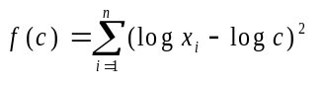

a. df/dc=2E(log(xi)-logc)=2Elogxi-nlogc
cannot use chain rule, base not specified.
- Find the statistic that maximizes the function: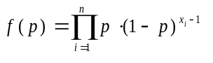

f(p)=(p^n)(1-p)^[E(xi-1)], lnf=(nlnp)+E(x-1)ln(1-p).

dL/dp=n/p+E(xi-1)/(1-p)=0, n/p=-E(xi-1)/(1-p), n((1-p)/p)-1)=n(((1/p)-1)-1)

=n((1/p)-2), (1/p)=2-[E(xi)/n], p=1/(2-[E(xi)]/n).
- In the Iris data, find the overall mean, median, and mode of the four variables Sepal.Length, Sepal.Width, Petal.Length, and Petal.Width.

R>attach(iris)
R>iris

- In the Iris data, find the overall range, variance, and standard deviation of the four variables Sepal.Length, Sepal.Width, Petal.Length, and Petal.Width.

> x=Sepal.Length
> mode<-function(x)
+ {ux<-unique(x)
+ ux[which.max(tabulate(match(x,ux)))]}
> mode(x)
[1] 5
> c(mean(x),median(x),mode(x))
[1] 5.843333 5.800000 5.000000
x=Sepal.Width
> c(mean(x),median(x),mode(x))
[1] 3.057333 3.000000 3.000000
> x=Petal.Length
> c(mean(x),median(x),mode(x))
[1] 3.758 4.350 1.400
> x=Petal.Width
> c(mean(x),median(x),mode(x))
[1] 1.199333 1.300000 0.200000

- Find the mean, median, and mode of the variables Sepal.Length, Sepal.Width, Petal.Length, and Petal.Width separated by each species.

setosa=iris[1:50,]
versicolor=iris[51:100,]
virginica=iris[101:150,]

> setosa
x=Sepal.Length
c(mean(x),median(x),mode(x))
[1] 5.843333 5.800000 5.000000
> x=Sepal.Width
> c(mean(x),median(x),mode(x))
[1] 3.057333 3.000000 3.000000
x=Petal.Length
> c(mean(x),median(x),mode(x))
[1] 3.758 4.350 1.400
x=Petal.Width
> c(mean(x),median(x),mode(x))
[1] 1.199333 1.300000 0.200000

> versicolor
> a=Sepal.Length
> b=Sepal.Width
> c=Petal.Length
> d=Petal.Width
> c(mean(a),median(a),mode(a))
[1] 5.843333 5.800000 5.000000
> c(mean(b),median(b),mode(b))
[1] 3.057333 3.000000 3.000000
> c(mean(c),median(c),mode(c))
[1] 3.758 4.350 1.400
> c(mean(d),median(d),mode(d))
[1] 1.199333 1.300000 0.200000

> virginica
x=Sepal.Length + Sepal.Width + Petal.Length + Petal.Width
> c(mean(x),median(x),mode(x))
[1] 13.858 14.300 10.200
> x=Sepal.Length(a) + Sepal.Width(b) + Petal.Length(c) + Petal.Width(d)
Error in Sepal.Length(a) : could not find function "Sepal.Length"
> a=Sepal.Length
> b=Sepal.Width
> c=Petal.Length
> d=Petal.Width
> c(mean(a),median(a),mode(a))
[1] 5.843333 5.800000 5.000000
> c(mean(b),median(b),mode(b))
[1] 3.057333 3.000000 3.000000
> c(mean(c),median(c),mode(c))
[1] 3.758 4.350 1.400
> c(mean(d),median(d),mode(d))
[1] 1.199333 1.300000 0.200000

- Find the range, variance, and standard deviation of the variables Sepal.Length, Sepal.Width, Petal.Length, and Petal.Width separated by each species.

> max(a)-min(a)
[1] 3.6
> max(b)-min(b)
[1] 2.4
> max(c)-min(c)
[1] 5.9
> max(d)-min(d)
[1] 2.4
> var(a)
[1] 0.6856935
> var(b),var(c)
Error: unexpected ',' in "var(b),"
> var(b)
[1] 0.1899794
> var(c)
[1] 3.116278
> var(d)
[1] 0.5810063
> sd(a)
[1] 0.8280661
> sd(b)
[1] 0.4358663
> sd(c)
[1] 1.765298
> sd(d)
[1] 0.7622377

versicolor
> s(a)=c(max(a)-min(a),var(a),sd(a))
Error in s(a) = c(max(a) - min(a), var(a), sd(a)) :
could not find function "s<-"
> c(max(a)-min(a),var(a),sd(a))
[1] 3.6000000 0.6856935 0.8280661
> c(max(b)-min(b),var(b),sd(b))
[1] 2.4000000 0.1899794 0.4358663
> c(max(c)-min(c),var(c),sd(c))
[1] 5.900000 3.116278 1.765298
> c(max(d)-min(d),var(d),sd(d))
[1] 2.4000000 0.5810063 0.7622377

virginica
> c(max(a)-min(a),var(a),sd(a))
[1] 3.6000000 0.6856935 0.8280661
> c(max(b)-min(b),var(b),sd(b))
[1] 2.4000000 0.1899794 0.4358663
> c(max(c)-min(c),var(c),sd(c))
[1] 5.900000 3.116278 1.765298
> c(max(d)-min(d),var(d),sd(d))
[1] 2.4000000 0.5810063 0.7622377

- Produce a correlation matrix of the variables Sepal.Length, Sepal.Width, Petal.Length, and Petal.Width separated by each species.

- Produce a scatterplot matrix of the variables Sepal.Length, Sepal.Width, Petal.Length, and Petal.Width separated by each species.

(7^8 are combined)

setosa
> cor(Sepal.Length,Sepal.Width)
[1] -0.1175698
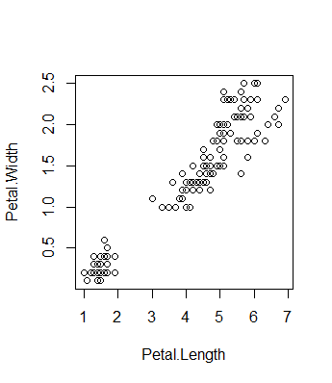
> cor(Petal.Length, Petal.Width)[1] 0.9628654

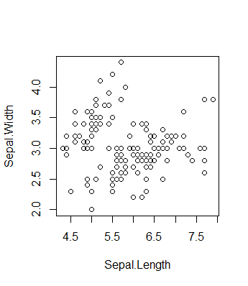
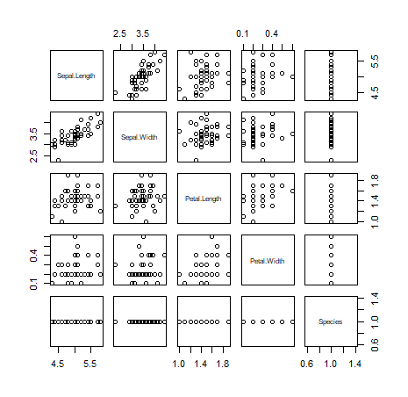
plot(Sepal.Length,Sepal.Width)
> plot(Petal.Length,Petal.Width)
> pairs(Setosa)
Error in pairs(Setosa) : object 'Setosa' not found
> pairs(setosa)
> plot(setosa)
> cor setosa
Error: unexpected symbol in "cor setosa"
> cor(setosa)
Error in cor(setosa) : 'x' must be numeric
> plot(setosa)

versicolor
cor(Sepal.Length,Sepal.Width)
[1] -0.1175698
> cor(Petal.Length, Petal.Width)
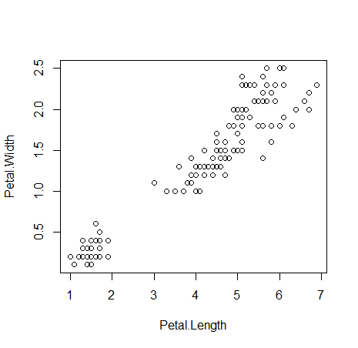
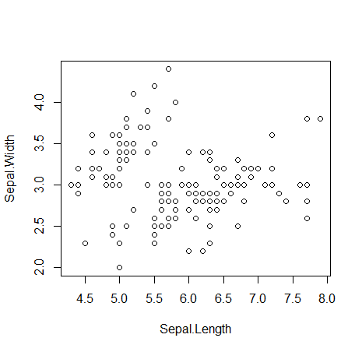
[1] 0.9628654

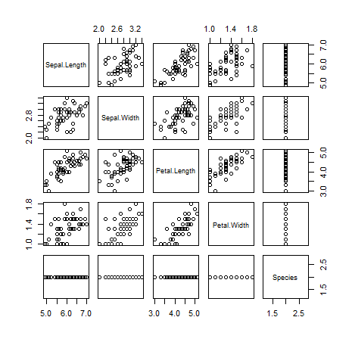
> plot(Sepal.Length,Sepal.Width)
> plot(Petal.Length,Petal.Width)
> pairs(versicolor)

virginica
> cor(Sepal.Length,Sepal.Width)
[1] -0.1175698
> cor(Petal.Length,Petal.Width)
[1] 0.9628654
plot(Sepal.Length,Sepal.Width)
> plot(Petal.Length,Petal.Width)
> pairs(virginica)
